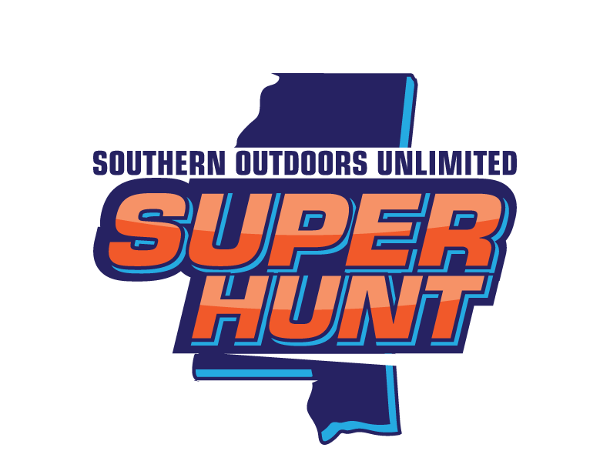

2018 Super Hunt Medical Form

Patient’s Name

Birth Date

Address

Parent/Guardian Name

Telephone Number

(To Be Filled Out By Physician)

Dear Physician,
The patient identified above has submitted an application to participate in the 2018 Super Hunt, a three-day deer hunting weekend for disabled youth sponsored by the MS Outdoors Unlimited. As part of the application process, please provide the following information:

Patient’s disability:

Patient’s Physical Limitations: ____________________________________________________________________

Medications:
(Dose & Time)

Are patient’s immunizations up to date?

Has patient received a tetanus shot or tetanus booster within the last three years? ________

Any Allergies: _______________________________________________________________________________________

Identify any special accommodations necessary to allow the patient to participate in the Super Hunt weekend: ________________________________________________________________________________________________________
________________________________________________________________________________________________________________________________________________________________________________________________________________________________________

Physician Name:

Physician Signature: _______________________________________________________________________________

Clinic Name and Address:

Telephone Number:

A COMPLETED MEDICAL FORM MUST BE SUBMITTED BY OCTOBER 1, 2018. THE COMPLETED FORM CAN BE EMAILED TO mumbower@gmail.com OR MAILED TO MS Outdoors Unlimited P.O. Box 2305 Ridgeland, MS 39158. HUNTER’S WILL NOT BE ALLOWED TO PARTICIPATE IF A COMPLETED MEDICAL FORM IS NOT RECEIVED BY THE DEADLINE.

